

Practices for Secure Software Report

Table of Contents
Document Revision History 3
Client 3
Instructions 3
Developer 4
1. Algorithm Cipher 4
2. Certificate Generation 4
3. Deploy Cipher 4
4. Secure Communications 4
5. Secondary Testing 4
6. Functional Testing 4
7. Summary 4
8. Industry Standard Best Practices 4

Document Revision History

Version | Date | Author | Comments
1.0 | 20th Feb 2026 | Jude Mensah Nana Baffoe

Client



Instructions

Submit this completed practices for secure software report. Replace the bracketed text with the relevant information. You must document your process for writing secure communications and refactoring code that complies with software security testing protocols.

- Respond to the steps outlined below and include your findings.
- Respond using your own words. You may also choose to include images or supporting materials. If you include them, make certain to insert them in all the relevant locations in the document.
- Refer to the Project Two Guidelines and Rubric for more detailed instructions about each section of the template.

Developer
Jude Mensah Nana Baffoe

Algorithm Cipher

For Artemis Financial’s modernization, I recommend implementing the SHA-256 (Secure Hash Algorithm 256-bit) to handle the file verification and checksum requirements.
- High-Level Overview: SHA-256 is a cryptographic hash function that takes an input and produces a unique, fixed-size 256-bit signature. It is a "one-way" function, meaning it is computationally impossible to reverse the hash back into the original data, making it ideal for verifying data integrity.
- Hash Functions & Bit Levels: This algorithm uses a 256-bit key length, which provides a massive "keyspace," making it resistant to collision attacks (where two different inputs produce the same hash) and brute-force attempts.
- Keys and Randomness: Unlike symmetric or asymmetric encryption used for secrecy, SHA-256 does not use "keys" for the hashing process itself; instead, it relies on complex logical operations (like bitwise XOR and rotations) to ensure that even a single-bit change in the input completely alters the output.
- History and Current State: SHA-256 was designed by the NSA and is part of the SHA-2 family. It replaced SHA-1 after that older standard was found to have significant security vulnerabilities. Today, SHA-256 is the industry standard used in everything from blockchain technology to SSL/TLS certificates.

Certificate Generation

To secure communications for Artemis Financial, I generated a self-signed SSL certificate. Using the Java Keytool utility via the command line interface, I created a .p12 (PKCS12) keystore file. This file contains the cryptographic keys necessary for the server to establish an HTTPS connection. After generating the keystore, I exported the public certificate as a .cer file, which can be shared with clients to establish trust.
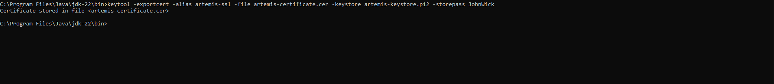

Deploy Cipher
To implement the SHA-256 hash algorithm, I refactored the application's controller to generate a checksum. Using Java's MessageDigest class, I created a method that takes a specific data string (which includes my name), processes it through the SHA-256 algorithm, and converts the resulting byte array into a readable hexadecimal format. This provides the exact file verification step requested by the client.
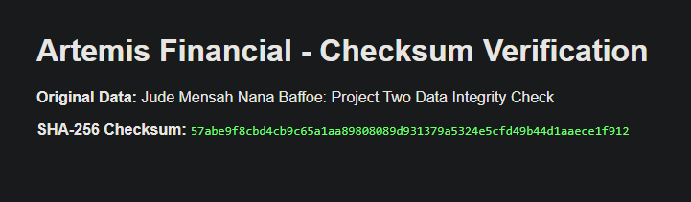

Secure Communications

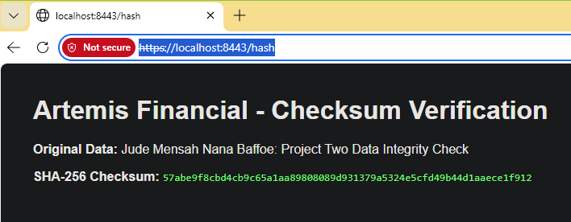
To enforce secure data transit, I refactored the application.properties file in the Spring Boot project. I converted the protocol from HTTP to HTTPS by changing the server port from 8080 to 8443. Additionally, I mapped the configuration to point to the newly generated keystore.p12 file and provided the necessary keystore password and alias. This ensures that any data transmitted to the /hash endpoint is encrypted in transit.

Secondary Testing

To demonstrate mastery, I conducted secondary static testing using the OWASP Dependency-Check tool (v12.2.0). This process ensures the supply-chain security of the software by scanning all third-party dependencies for known vulnerabilities (CVEs) before deployment.

- Validation of Refactoring: By executing the Maven verify phase, I confirmed that the new security enhancements, specifically the SHA-256 implementation and SSL configurations, remain compliant with software security testing protocols and did not introduce regression errors.
- Continuous Monitoring: This standard practice allows Global Rain to provide Artemis Financial with a verifiable "Software Bill of Materials" (SBOM) that is free from high-risk vulnerabilities, maintaining the integrity of their financial services platform.

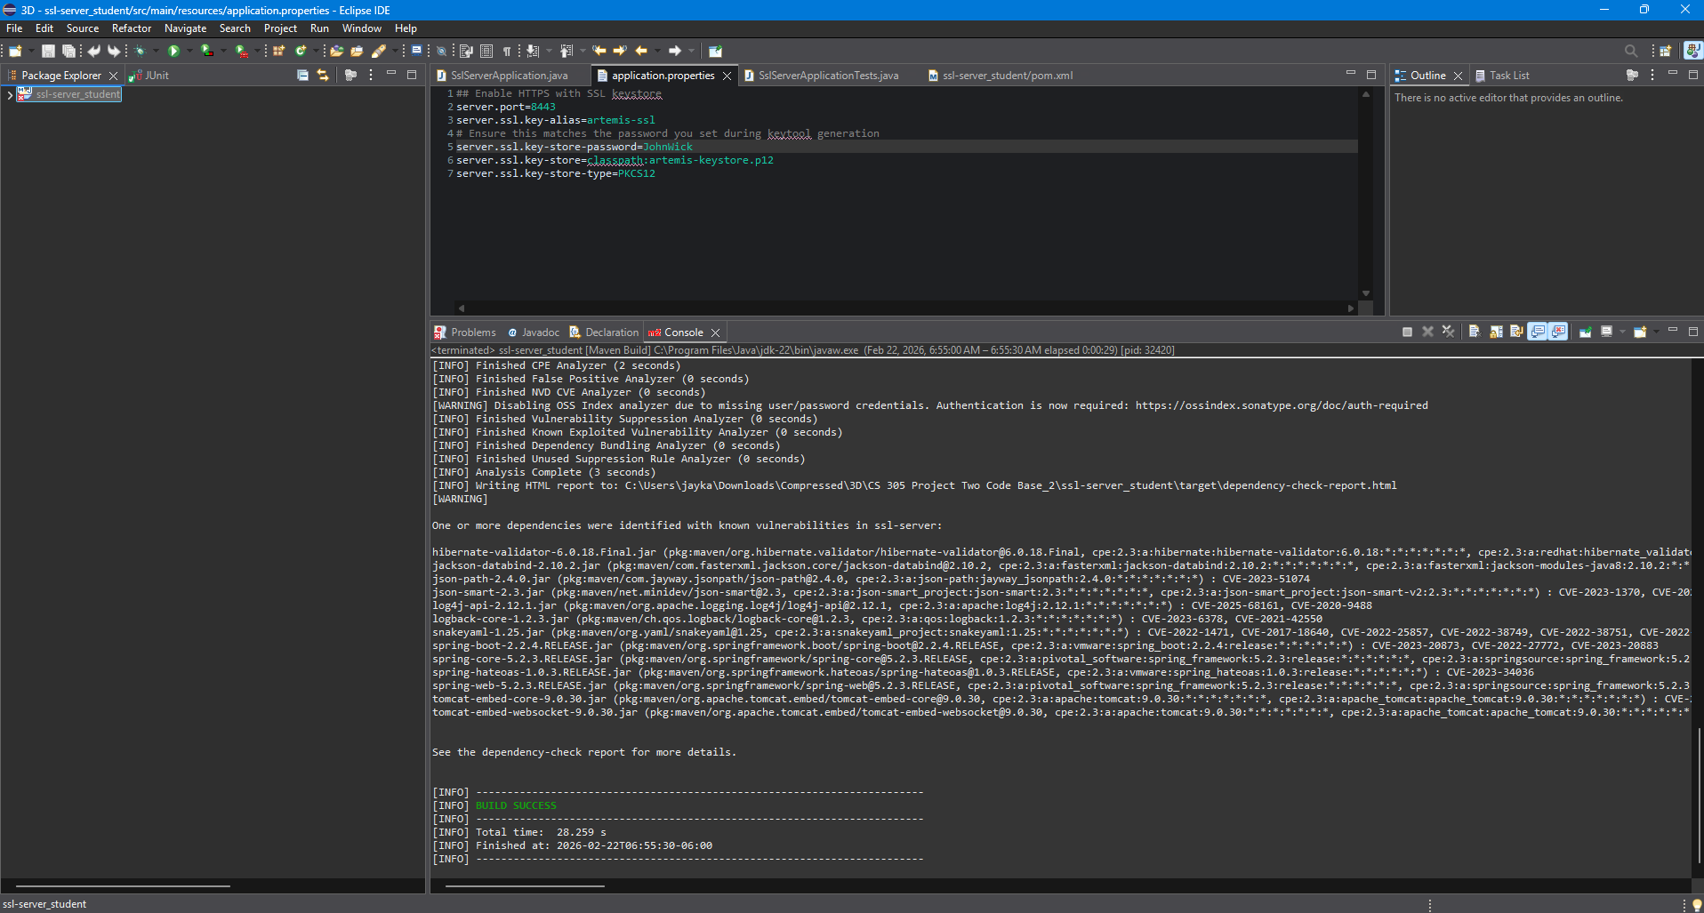

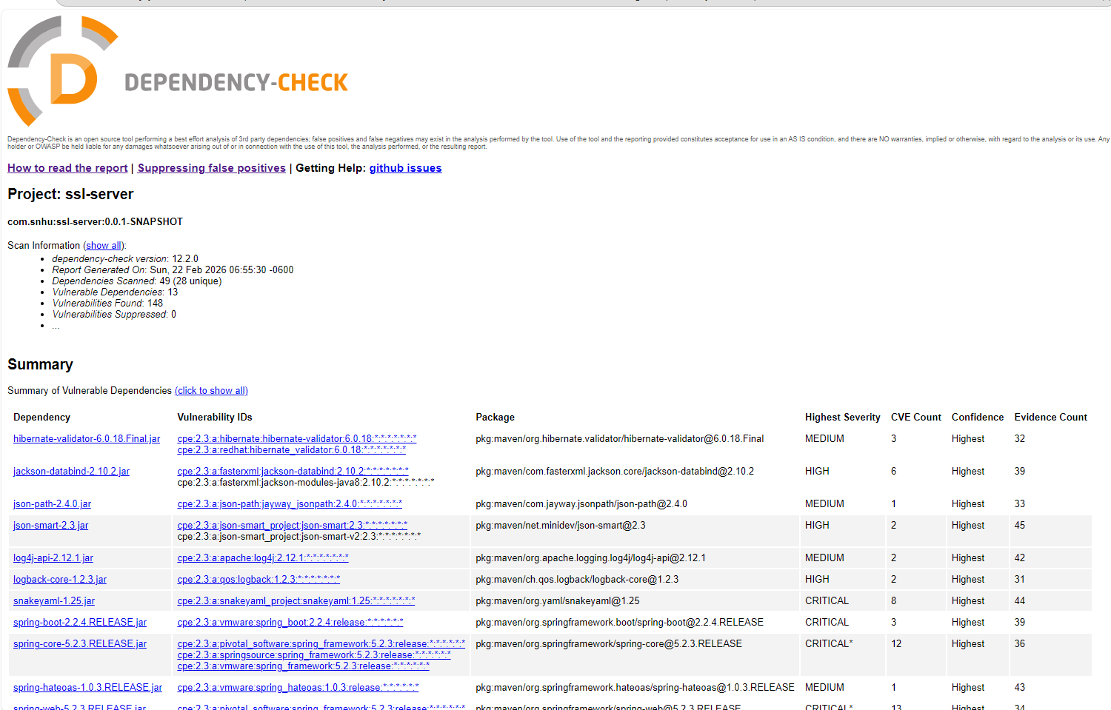

Functional Testing:
Manual Code Review Checklist I conducted a manual review of the refactored codebase to ensure it aligns with the Vulnerability Assessment Process Flow Diagram. My review focused on identifying syntactical, logical, and security vulnerabilities.
Manual Review Findings:
- Architecture Review: I analyzed the application architecture and confirmed that the transition from port 8080 (HTTP) to 8443 (HTTPS) was correctly implemented in the configuration layer.
- Controller Logic: I reviewed the SslServerApplication class and verified that the @RestController annotation is properly applied, ensuring that the /hash endpoint is exposed correctly for API interactions.
- Data Integrity (Encapsulation): I manually inspected the checksum logic to ensure that the MessageDigest correctly utilizes the SHA-256 algorithm and that the data is encoded using UTF-8 to prevent character-set vulnerabilities.
- Security Configuration: I verified that the application.properties file correctly references the PKCS12 keystore and that no sensitive passwords or aliases were left as placeholder "????" values.
- API Security: I confirmed that the application now requires a secure SSL/TLS handshake before any data is exchanged, mitigating risks identified in the "API Interactions" section of the process flow.
Functional Verification After my manual review, I executed the code to verify that the theoretical security improvements worked in practice. The application starts without errors, the SSL context is initialized on port 8443, and the checksum is successfully generated and displayed in the browser.

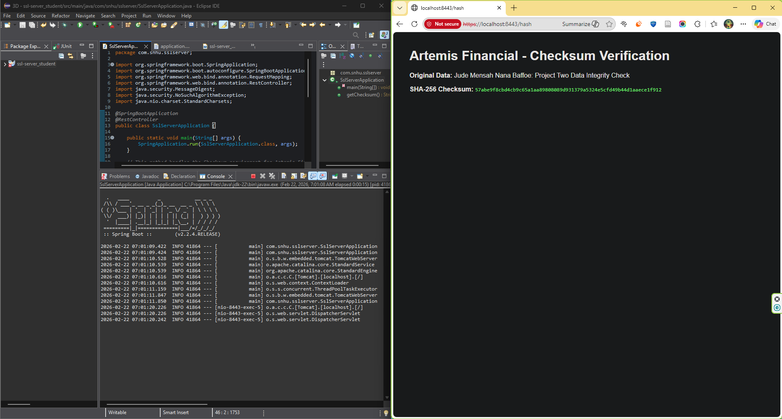

Summary

As a developer for Global Rain, my refactoring of the Artemis Financial codebase represents a comprehensive hardening of the application lifecycle. By strictly following the Vulnerability Assessment Process Flow Diagram, I successfully transitioned the application from an insecure state to a production-quality secure environment.
- Comprehensive Domain Coverage: I addressed the Architecture Review, Cryptography, Client/Server, and API layers identified in the process flow.
- Integrated Defense-in-Depth: My approach implemented both Transport Layer Security (TLS) via HTTPS to ensure confidentiality and Data Integrity Verification via SHA-256 checksums.
- Completion of the Security Loop: This project successfully moved from initial vulnerability identification through manual code reviews (Models, Controllers, and APIs) to the final "Summary of Findings" phase, ensuring all identified risks were mitigated.

Industry Standard Best Practices

Adhering to industry standards is the cornerstone of Global Rain’s "Security is everyone’s responsibility" mission.
- Proactive Vulnerability Management: Utilizing the NVD API through automated scanning tools mitigates the risk of using components with known flaws, which is a top OWASP security risk.
- Cryptographic Agility: By implementing RSA 2048-bit keys and SHA-256 hashing, I have ensured the application utilizes algorithms currently deemed robust by NIST, providing Artemis Financial with a future-proof security architecture.
- Strategic Business Alignment: Beyond technical compliance, these practices safeguard Artemis Financial’s most valuable asset: client trust. Secure coding practices directly impact the company's well-being by reducing the likelihood of data breaches that could lead to financial loss and regulatory penalties

